

Database report

CS4416 Database Systems



stephen healy – 17234522, Adam kenihan – 17230659, Andrew Kelly 17210631

Table of Contents

What our Database is about 2

Entity-Relation Diagram 3

Example of Each Table 4

FD’s 5

Proof that each table is in 3NF 6

# 

# What our Database is about

# Entity-Relation Diagram

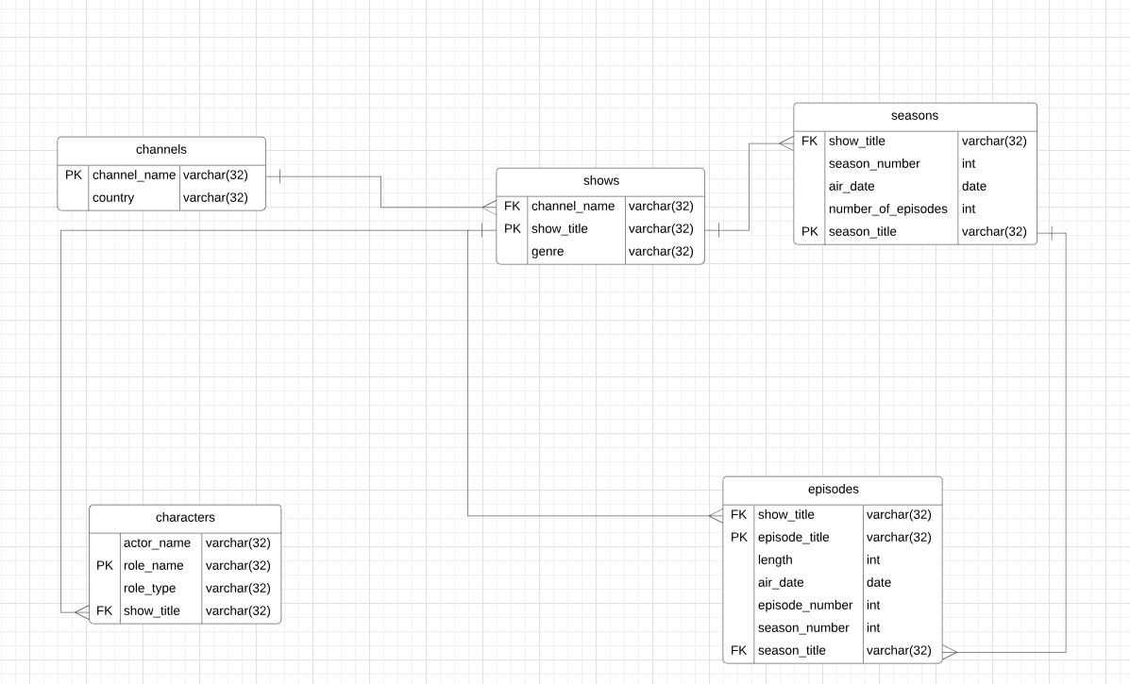

# Example of Each Table

# FD’s

# Proof that each table is in 3NF